Statement 4 by the Past-President, 8 June 2022
British Endodontic Society Statement on COVID-19 virus by The Past-President

As we approach the Summer period, the start of the COVID-19 pandemic seems an age ago and most of us have endured and survived the restrictions in both our personal and professional lives since 2020.
COVID-19 seems to now largely remain under control after the successful ongoing national vaccination programme since 2021.
Current Government guidance on infection prevention control has therefore changed to reflect the much-improved climate, with the emphasis on returning to pre-pandemic cleaning and working protocols in the healthcare and dental workplace environment particularly for our patients.
Patients and staff that do present with symptoms of respiratory disease or work in the presence of patients that are vulnerable to infection, still require special precautions as outlined in the latest IPC guidance: a salient reminder that the virus is still sporadically evident and that we still need to remain vigilant socially and at work!
Thankfully, those who do become infected seem to suffer with less severe and short-lived symptoms.
Hoping for a return to complete ‘normality’ over the next few months.
Best regards,
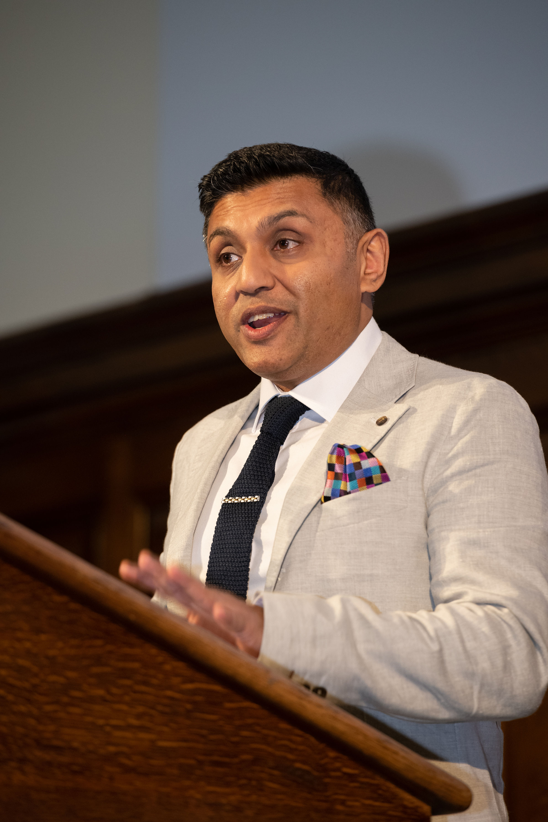

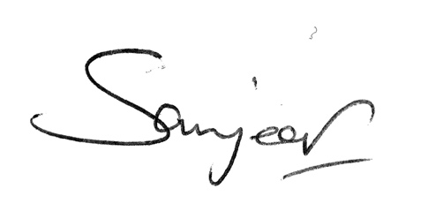

Dr Sanjeev Bhanderi (Past-President) and BES Council

